James Kennedy

Dr. Pulimood

CSC 415

2/23/2018

Individual Project Proposal

Digital privacy is a huge concern for a large majority of the population, considering that everyone carries a small computer filled with personal data, known as a smartphone. Millions of dollars of personal data is bought and sold everyday, and these days, some companies seem to hold people at a lesser value than the data they generate. This app will not be a sort of antivirus and more of a network monitor. While checking your smartphone using an antivirus is important, spyware may not always be detected by an antivirus, as well as the fact that the data you don’t want leaving your phone, may not be vulnerable to only malware. Most android applications ask for permissions the first time you launch them. Permission to access the camera or microphone, permission to access calls and texts, or permission to access local files and photos. But they never seem to ask permission to share they data they gather about you. I doubt this has ever only happened to me, but I have encountered several instances of me searching for a product on the internet, and then Amazon will start to advertise that product and products like it. While this may seem harmless, it is only one example. Big companies like Google are selling our digital portfolios to other companies that hope to make money off of it. This is why everyone is bothered by targeted advertising almost every time they browse the internet.

I plan to develop an android application that is able to monitor data and network usage in order to detect attempted data retrievals. This will allow the app to recognize if an app is trying to send data out, and if so perhaps where it is going or what it is sending. Ideally the app will send push notification warnings that will alert users to attempted data retrievals, review the situation and possibly choose a desired action such as allow or deny the data to go through. I chose to go with Option 2 because creating an original project sounded much more appealing to me.

To develop this application, I plan on writing this application in Java using Android Studio. Potential data structures that I may implement include an array to hold certain information such as trusted networks and applications. I could also implement a tree that could be used for logical processing when deciding how to categorize/label certain network activity. The primary algorithms that I will have to write include an algorithm that is able to check network and data usage and is able to identify possible threats. Once these potential threats are detected, another algorithm will have to assess the situation and choose whether to deam is harmless or dangerous to the user’s data. I will need to reinforce my Java skills as well as learn new Java libraries that are unique to the Android platform. Most importantly I need to study methods for accessing data and network usage as well as how to read in these logs as data that my algorithms can process.

The MIT license is a permissive open source license that lets users do anything they want with the software, as long as attribution is given to the original work and is not held for liability. A copyright OSS like Apache 2.0 is concerned with copyright protection, and is nearly the same as permissive except that the copyright/patent notice must be included in redistributions. The GNU GPLv3 copyleft license is a more specific license that requires derivative work to also make source code available as well under the same terms as the original license as well as grant patent from contributors to users. By looking at these three, I believe that a permissive MIT-like license is best for me because I have no concerns over patents or copyright, I’m only concerned with maintaining credit for my original work.

Github Wiki: https://github.com/jamestk97/NetworkMonitorApp/wiki

Use-Case Diagram:

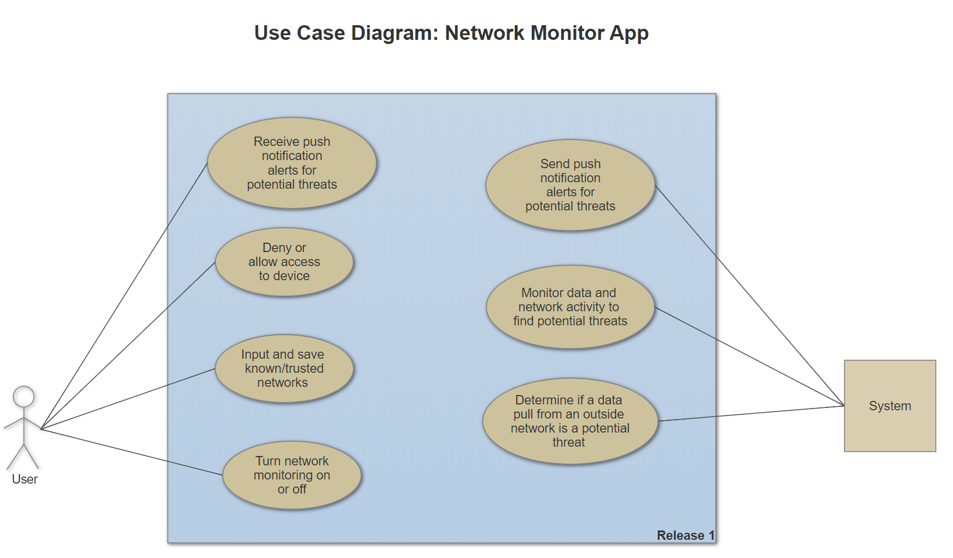

Gantt Chart:

